Laddering In Project Management
Student’s Name
Institutional Affiliation

The Early start (ES), Early Finish (EF), Late Start (LS), Late Finish (LF) and Total Slack (TS) for each activity is shown in Figure 1. As shown in Figure 1, the ES, EF, LS, LF and TS for the first activity Trench are Mon 12-10-09, Mon 12-10-09, Mon 12-10-09, Tue 13-10-09 and 0 days respectively. For the second Trench activity, ES, EF, LS, LF and TS are Fri 16-10-09, Fri 16-10-09, Wed 21-10-09, Thu 22-10-09 and 3 days respectively. For the third Trench activity, the values for ES, EF, LS, LF and TS are Thu 22-10-09, Thu 22-10-09, Tue 27-10-09, Wed 28-10-09 and 3 days respectively. In the first Lay Pipe activity, ES = (Fri 16-10-09), EF = (Fri 16-10-09), LS= (Fri 16-10-09), LF= (Mon 19-10-09) and TS = (0 days). For the second Lay Pipe activity, ES = (Thu 22-10-09), EF = (Thu 22-10-09), LS= (Tue 27-10-09), LF= (Wed 28-10-09) and TS = (3days). For the third Lay Pipe activity, ES = (Wed 28-10-09), EF = (Wed 28-10-09), LS= (Mon 02-11-09), LF= (Tue 03-11-09) and TS = (3 days) (see Figure 1).
Finally, for the first Refill activity, ES = (Thu 22-10-09), EF = (Thu 22-10-09), LS= (Thu 22-10-09), LF= (Fri 23-10-09) and TS = (0 days). The second Refill, ES = (Wed 28-10-09), EF = (Wed 28-10-09), LS= (Wed 28-10-09), LF= (Thu 29-10-09) and TS = (0 days). And the last Refill, ES = (Tue 03-11-09), EF = (Tue 03-11-09), LS= (Tue 03-11-09), LF= (Tue 03-11-09) and TS = (0 days) (see Figure 1).
As seen in the Figures, activities on the critical path are the first Trench, first Lay Pipe and all the Refill activities. It will take 17 days to finish the project (see Figure 2). However, increasing an activity on the critical path by seven days will extend the project duration. For instance, if the last Refill activity is increased by seven days instead of the previous one day, the project duration will be 24 days. This will delay the end data to Thu 12-11-09 instead of the previous Tue 03-11-09. Thus, extending an activity on the critical path delays the end date of a project.
Figure 1: Early start, Early Finish, Late Start, Late Finish and Total Slack of the project
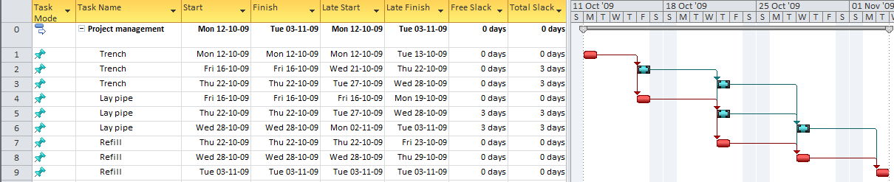
Figure 2: Project duration
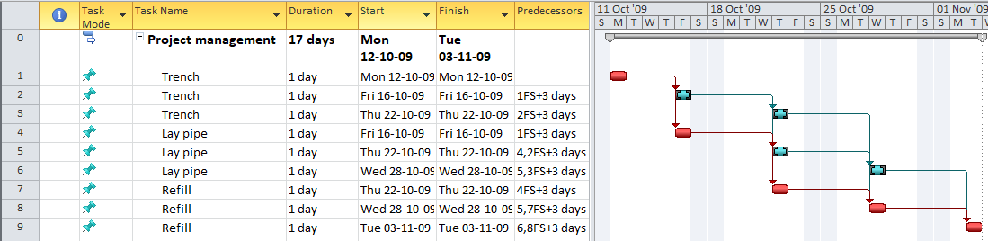

Figure 3: Impact of extending the critical activity duration on the project duration
